PARALLEL SEARCH ENGINE
ABSTRACT:
INTRODUCTION: -
Parallel Search Engine is a robust computing environment that harnesses the processing power of multiple, interconnected computers. If you divide a large task into sub-tasks and distribute the sub-tasks among multiple nodes, you can complete the task faster than if only one node did the work. This type of parallel processing is clearly more efficient than sequential processing. It also provides increased performance to process larger workloads and accommodate growing user populations.
The parallel Search Engine technology is now being implemented in the field like search engine, banks and also almost in every field which are based client - server architecture.
OBJECTIVE
The objective of this project is to develop a search engine which can be implemented locally in a computing environment like an educational institute or a small organization where information searching is mostly required.
TECHNOLOGY USED: -
Mostly parallel search engine concept based on the web application with the languages like JAVA, PHP or .NET the front end and with any of the RDBMS packages at the back end. Here during the above said development we are going to use the invincible programming language C with OPEN GL or GTK graphics as our front end and with MYSQL Database as our backend in UNIX environment.

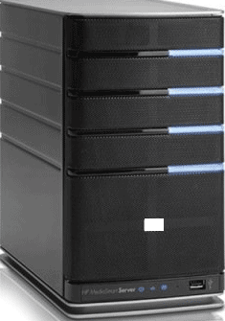



PROJECT ARCHITECTURE: -
SERVER1
SERVER3
SERVER2
CLIENT3
CLIENT2
CLIENT1
DESIGN:

STAGE-1

STAGE-2
SERVER1
SERVER3
SERVER2

CLIENT1
SERVER1
SERVER3
SERVER2
CLIENT2
CLIENT2




STAGE-3

CONCLUSION: -
Working with this project will reveal some of the secret power of C that still, as a programmer we are unaware of. During the development of this project it is going to explore the hidden treasures of C programming and will build a greater conceptual perceptive towards networking and internal architecture of networked nodes.

